**STA 216 Project:**

By: Nicolas Halstead

12/15/2022

**Data Source**

For this project, the group used a file named “homeless_prep.csv” found on Kaggle for this analysis. This dataset is focused on homeless veterans with multiple different factors, such as age, gender, income, and nights spent in homeless shelters.

**Research Question**

My research question was “How does the age of the homeless impact their length of stay in a homeless shelter. It would be quite interesting to see if age has any impact on how likely someone is to accept help from an outside source.

**Analysis**

Before entering anything into SAS I began by observing the dataset to attempt to find a model. Upon first inspection, it appeared that a simple linear regression would be optimal to analyze the data. I began by importing the data into SAS before running it through a linear regression. While the linear regression is not terribly accurate with an R-squared value of only 0.408, it is the best analysis for this data.

**Conclusions**

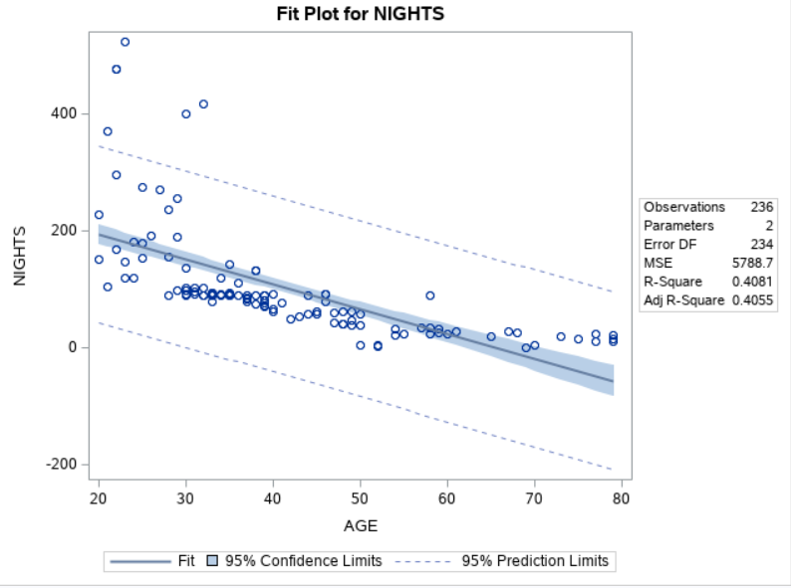

For most of the data above the age of 35, age proved to be a good predictor for the length of a homeless persons stay in a homeless shelter. Unfortunately, for ages under 35, the data broke down and age no longer possessed the predictive properties it had when the individuals age was higher.